Recorded Steps

This file contains all the steps and information that was recorded to help you describe the recorded steps to others.

Before sharing this file, you should verify the following:

* The steps below accurately describe the recording.
* There is no information below or on any screenshots that you do not want others to see.

Passwords or any other text you typed were not recorded, except for function and shortcut keys that you used.

You can do the following:

* Review the recorded steps
* [Review the recorded steps as a slide show](mhtml:file://C:\Users\MONICA\AppData\Local\Microsoft\UAR\Recording.mht!slide0001.htm)
* Review the additional details

Steps

Next

**Step 1: (‎02-‎05-‎2023 14:42:06)** User left double click on "Oracle VM VirtualBox (list item)" in "Program Manager"



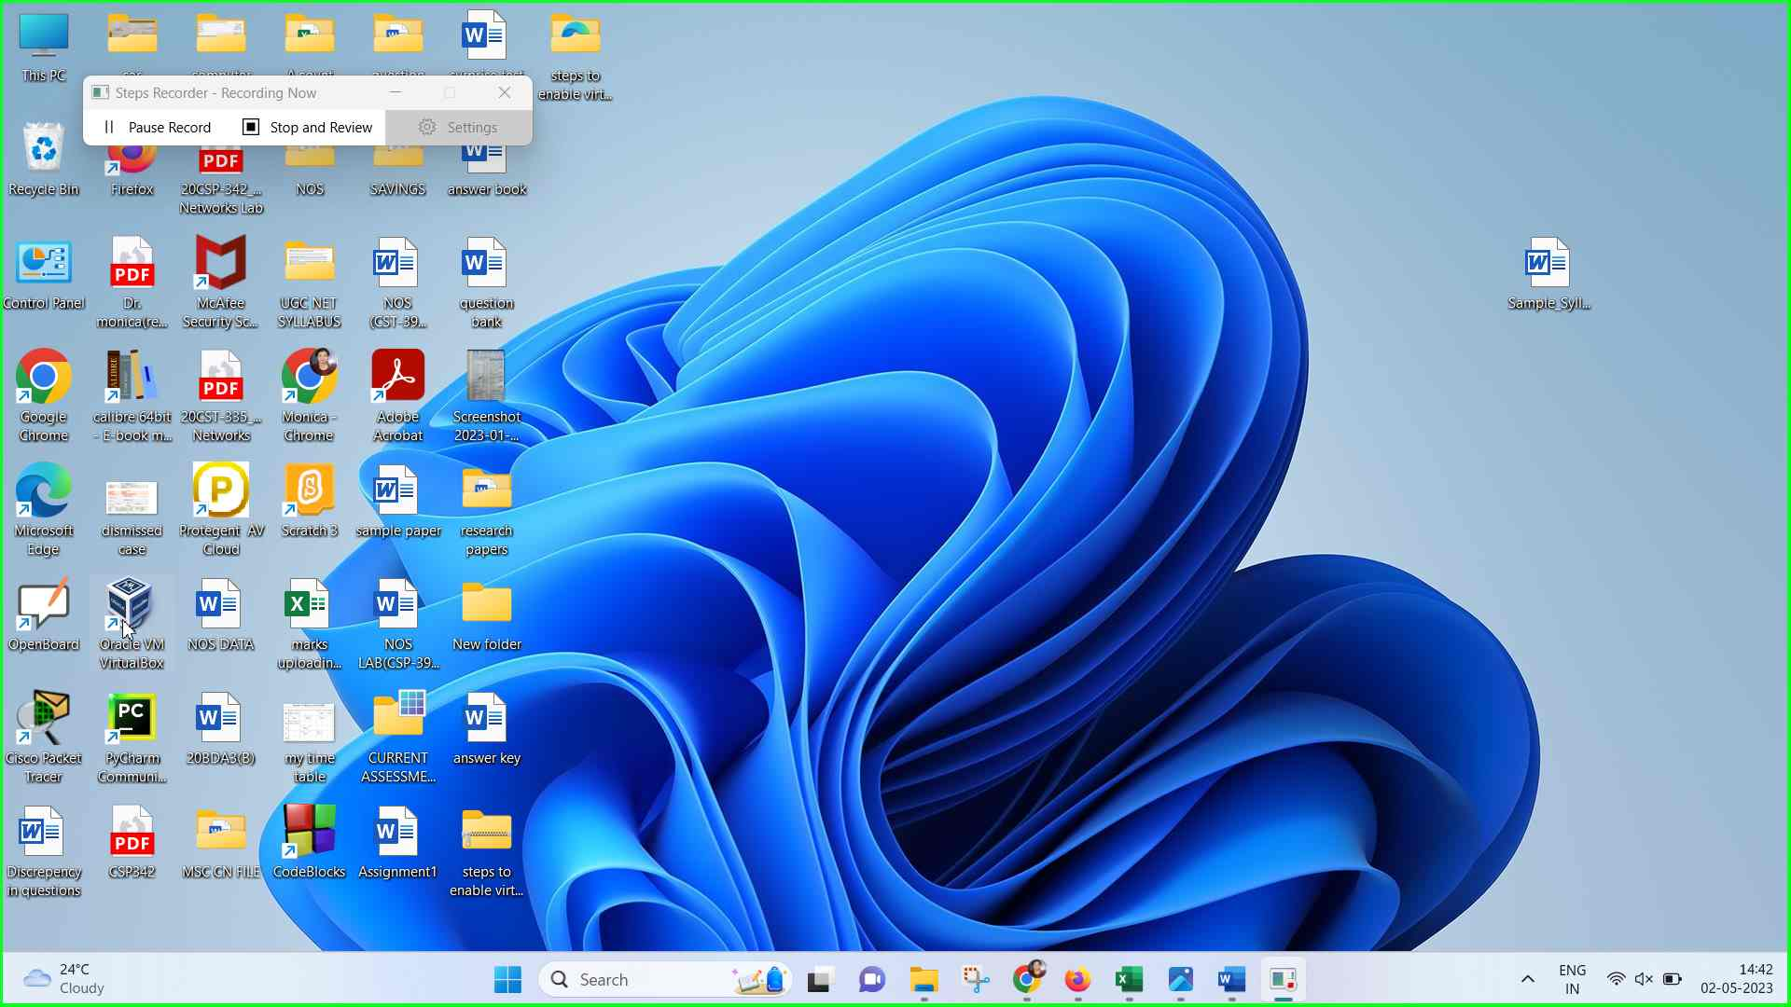Step 1 screenshot.

Previous Next

**Step 2: (‎02-‎05-‎2023 14:42:12)** User left click on "Settings (button)" in "Oracle VM VirtualBox Manager"



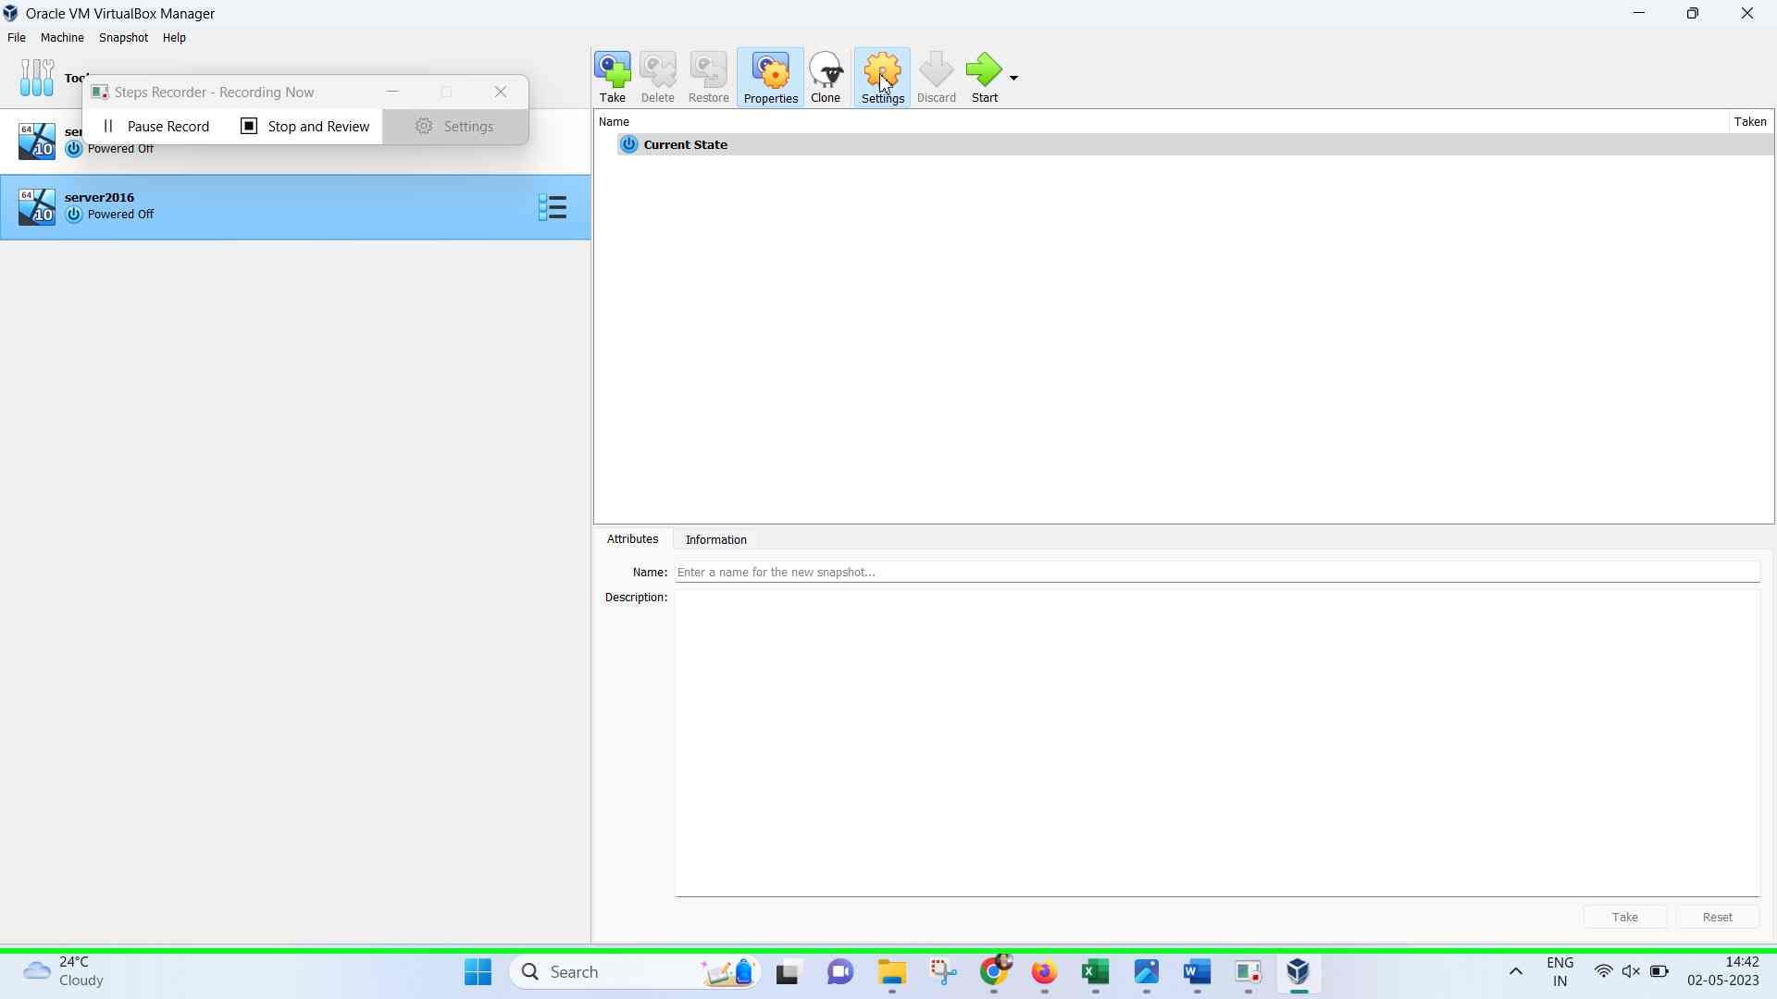Step 2 screenshot.

Previous Next

**Step 3: (‎02-‎05-‎2023 14:42:14)** User left click on " System (list item)" in "server2016 - Settings"



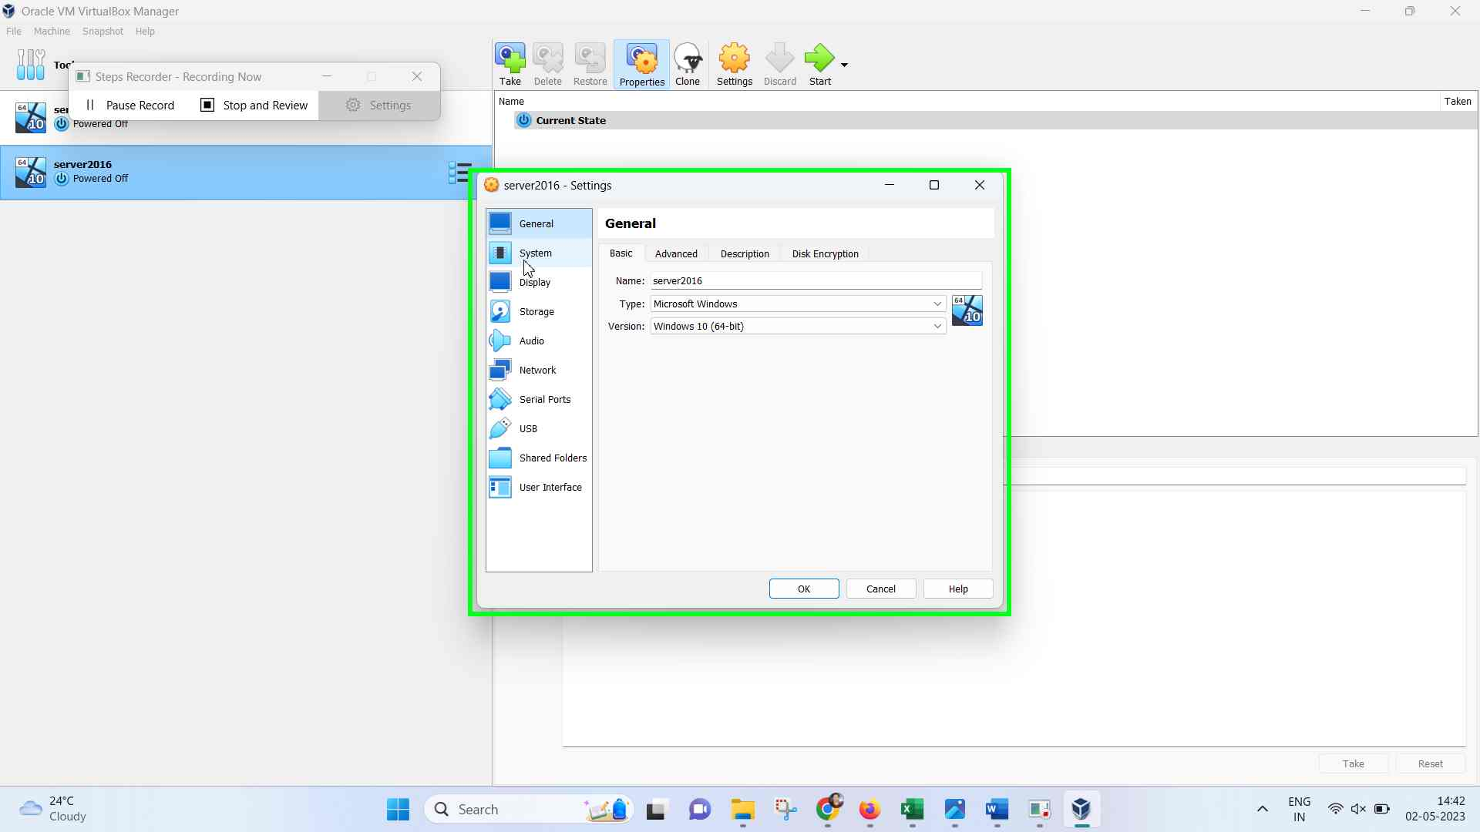Step 3 screenshot.

Previous Next

**Step 4: (‎02-‎05-‎2023 14:42:15)** User left click on "Processor (tab item)" in "server2016 - Settings"



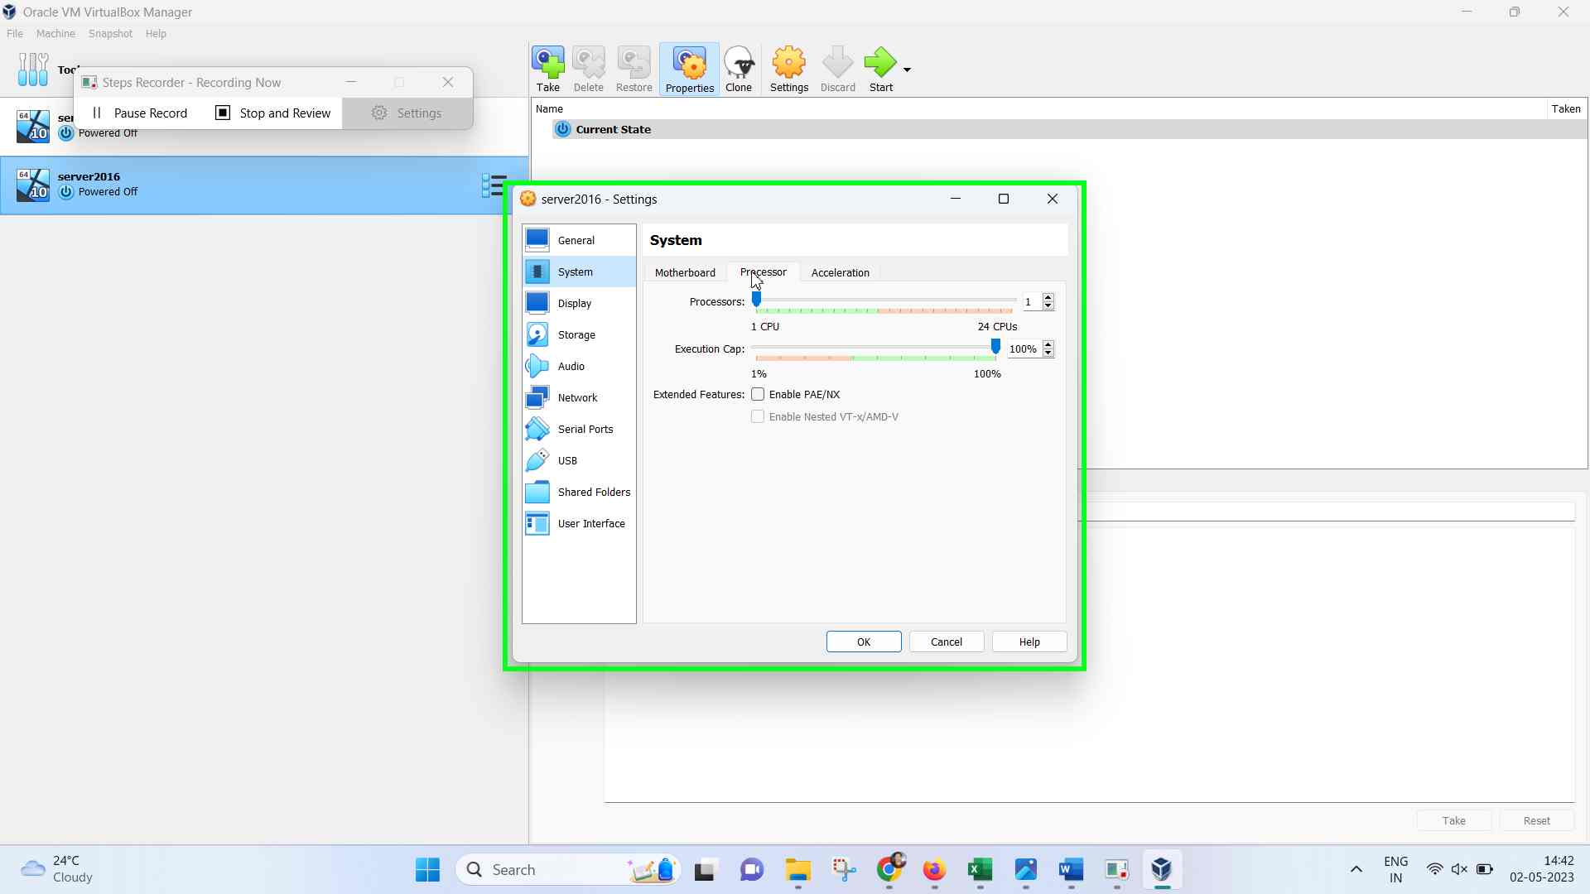Step 4 screenshot.

Previous Next

**Step 5: (‎02-‎05-‎2023 14:42:16)** User left double click on "Enable Nested VT-x/AMD-V (check box)" in "server2016 - Settings"



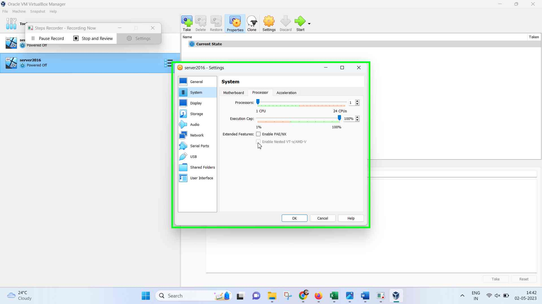Step 5 screenshot.

Previous Next

**Step 6: (‎02-‎05-‎2023 14:42:19)** User left click on "File Explorer - 3 running windows (button)"



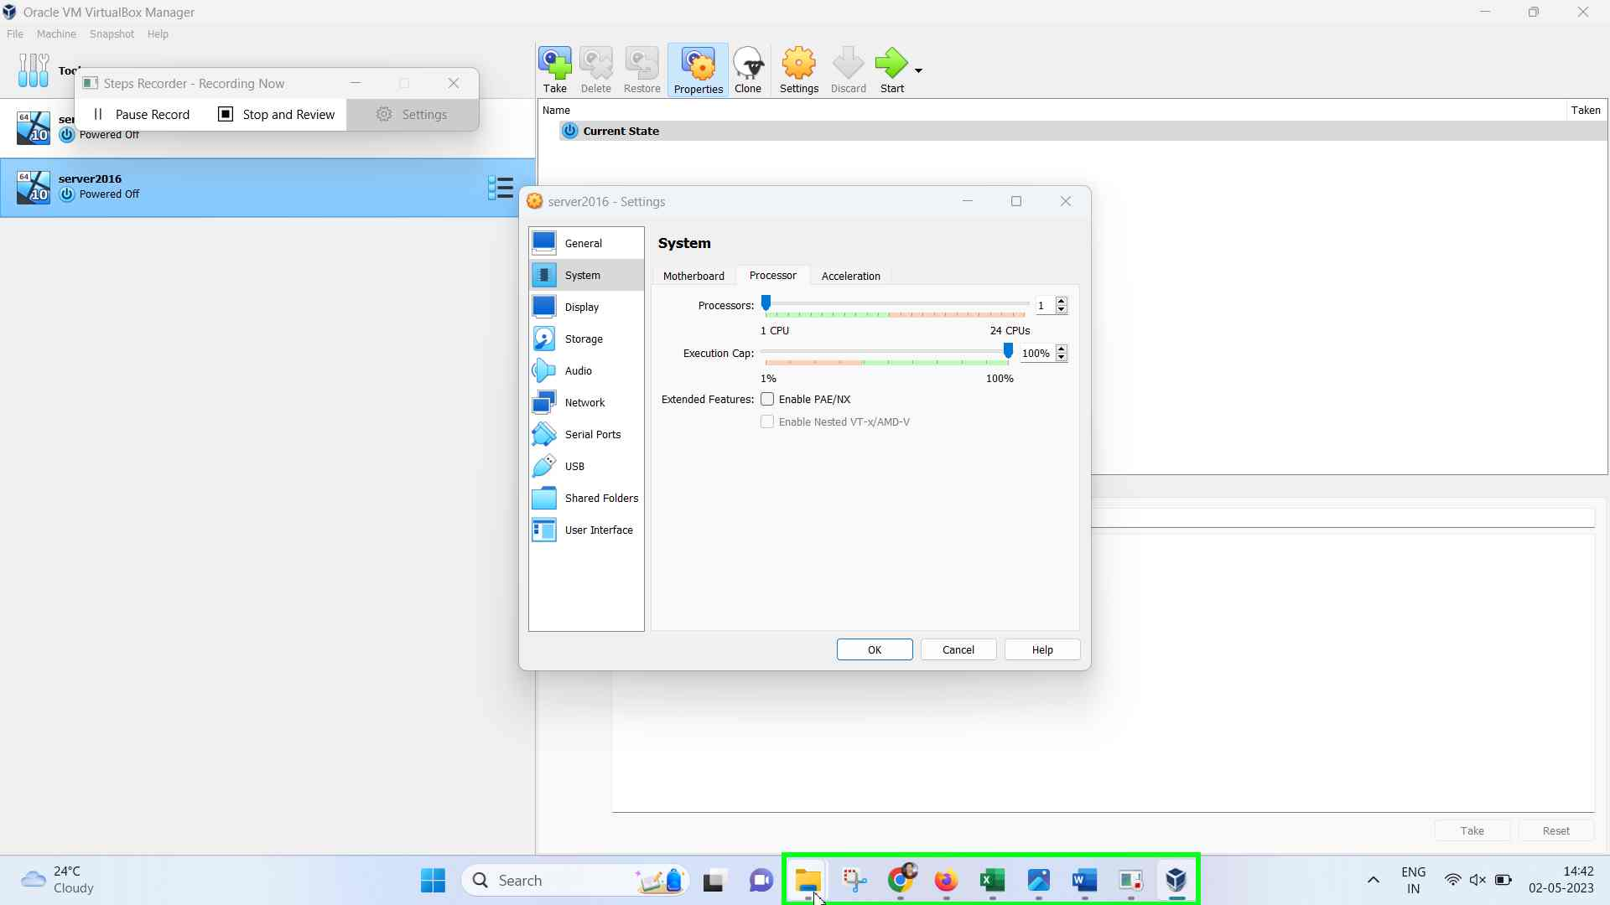Step 6 screenshot.

Previous Next

**Step 7: (‎02-‎05-‎2023 14:42:21)** User left click on "VirtualBox (list item)"



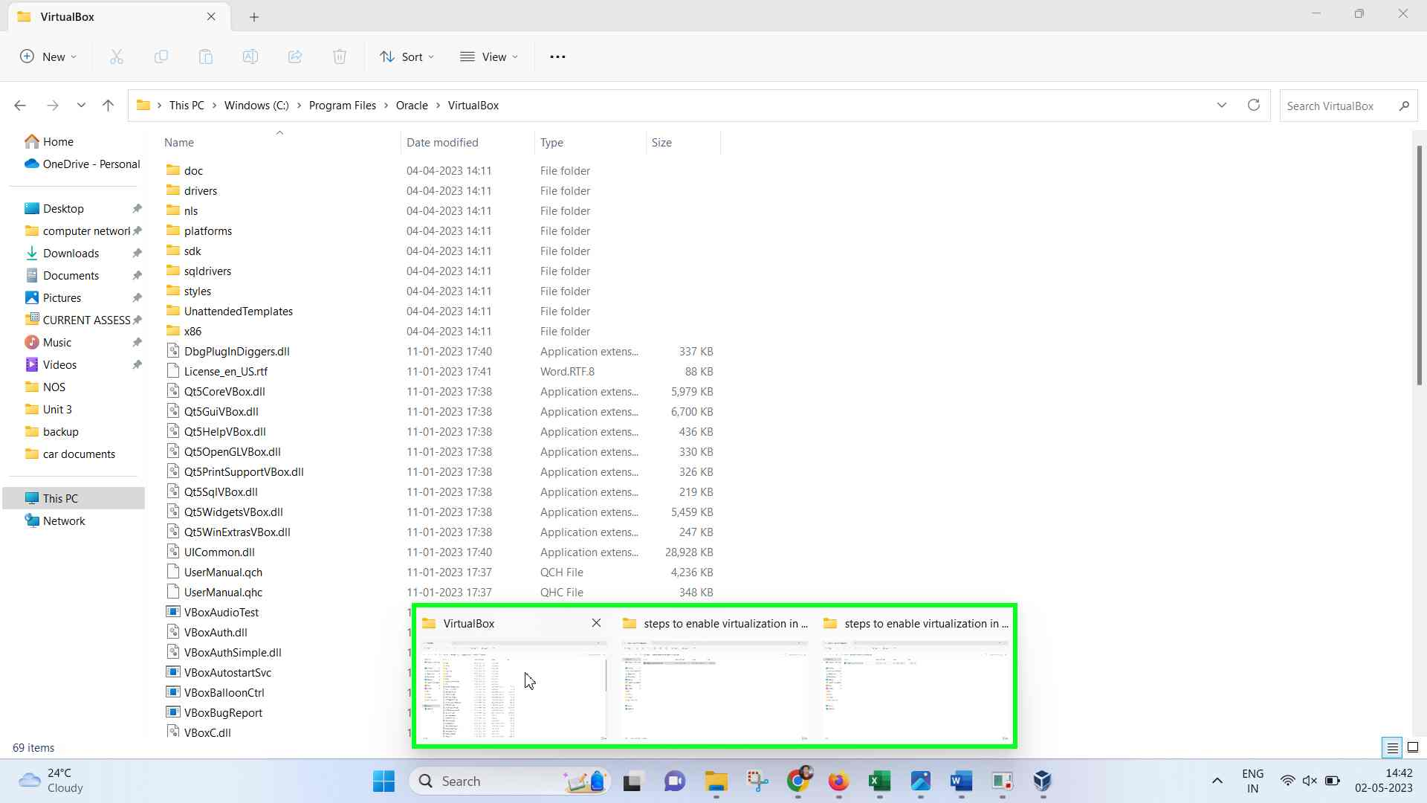Step 7 screenshot.

Previous Next

**Step 8: (‎02-‎05-‎2023 14:42:24)** User left click on "Address: C:\Program Files\Oracle\VirtualBox (tool bar)" in "VirtualBox"



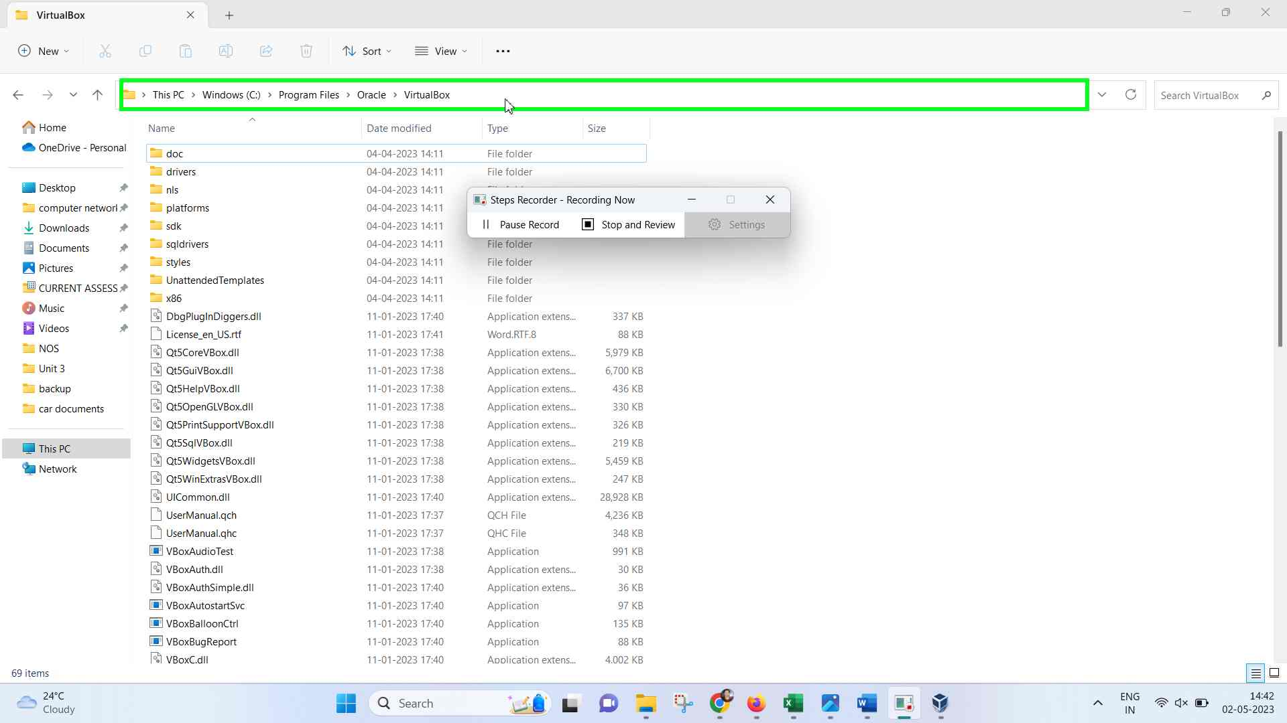Step 8 screenshot.

Previous Next

**Step 9: (‎02-‎05-‎2023 14:42:26)** User keyboard input on "Address (edit)" in "VirtualBox" [Left ... Enter]



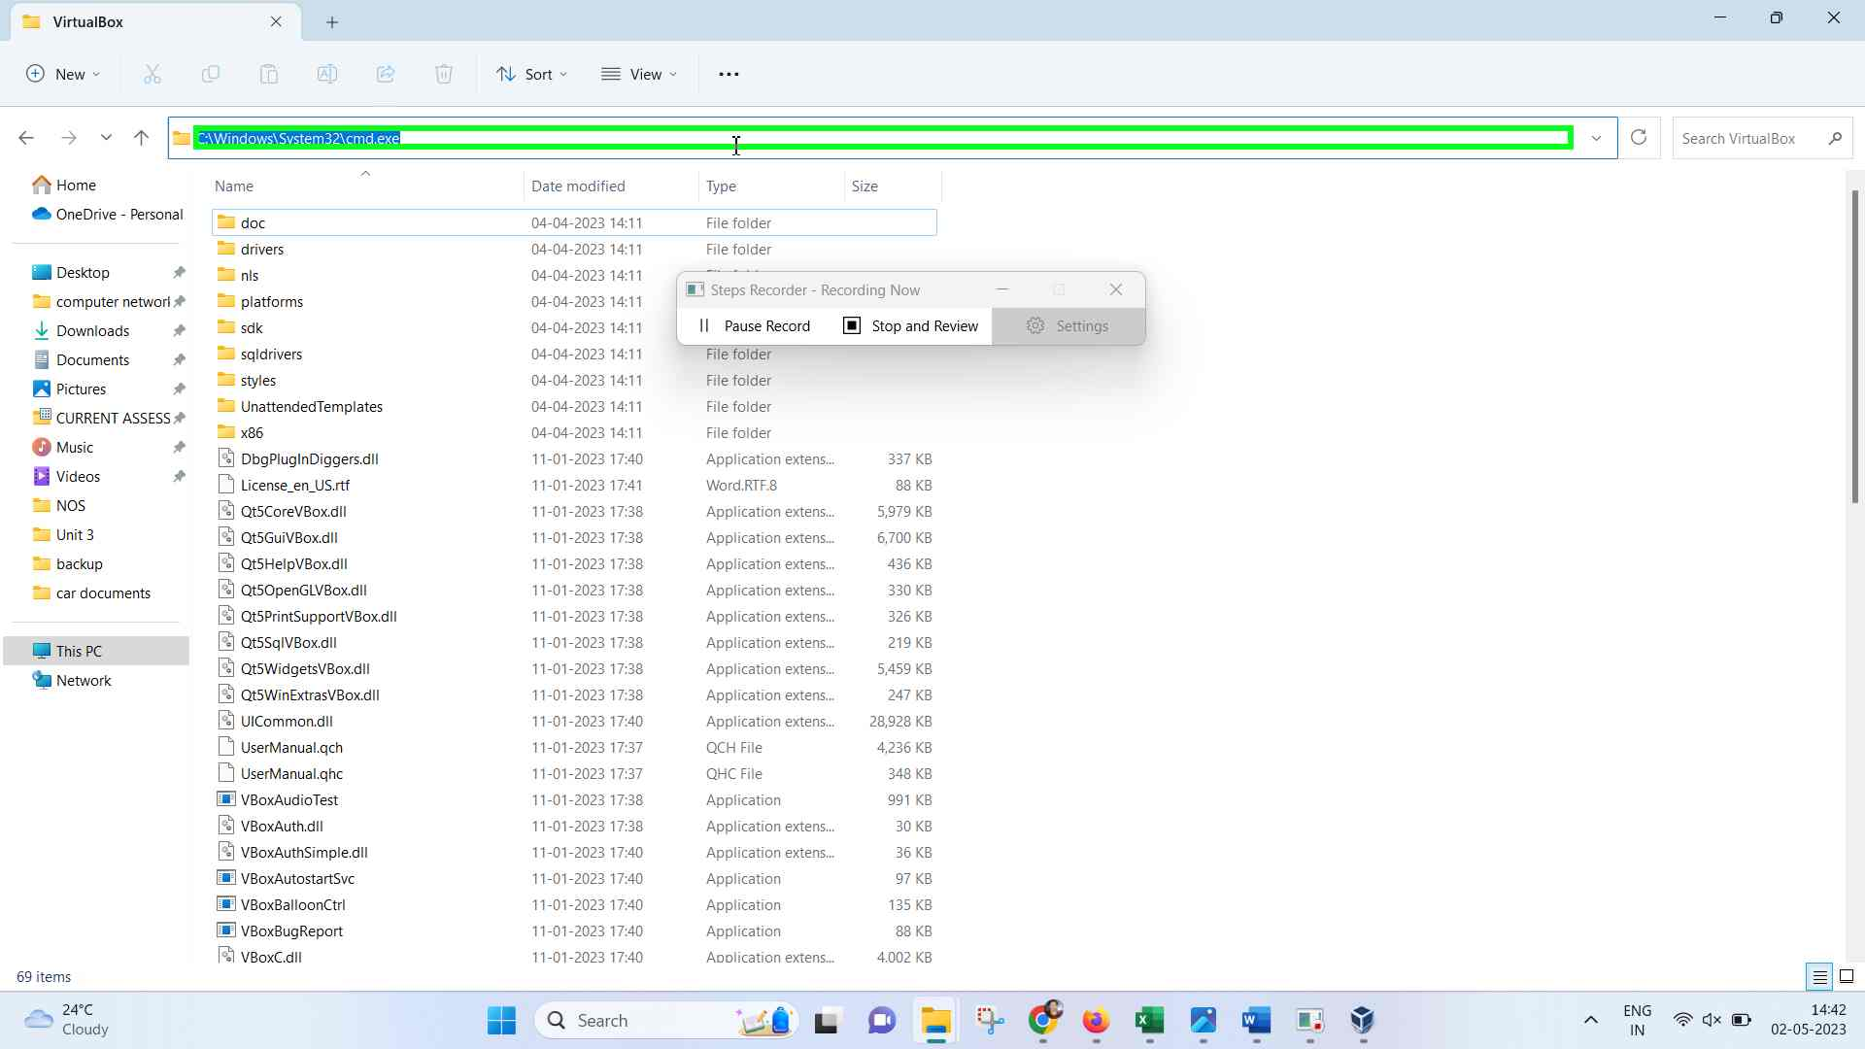Step 9 screenshot.

Previous Next

**Step 10: (‎02-‎05-‎2023 14:42:32)** User right click on "Command Prompt (terminal)" in "C:\Windows\System32\cmd.exe"



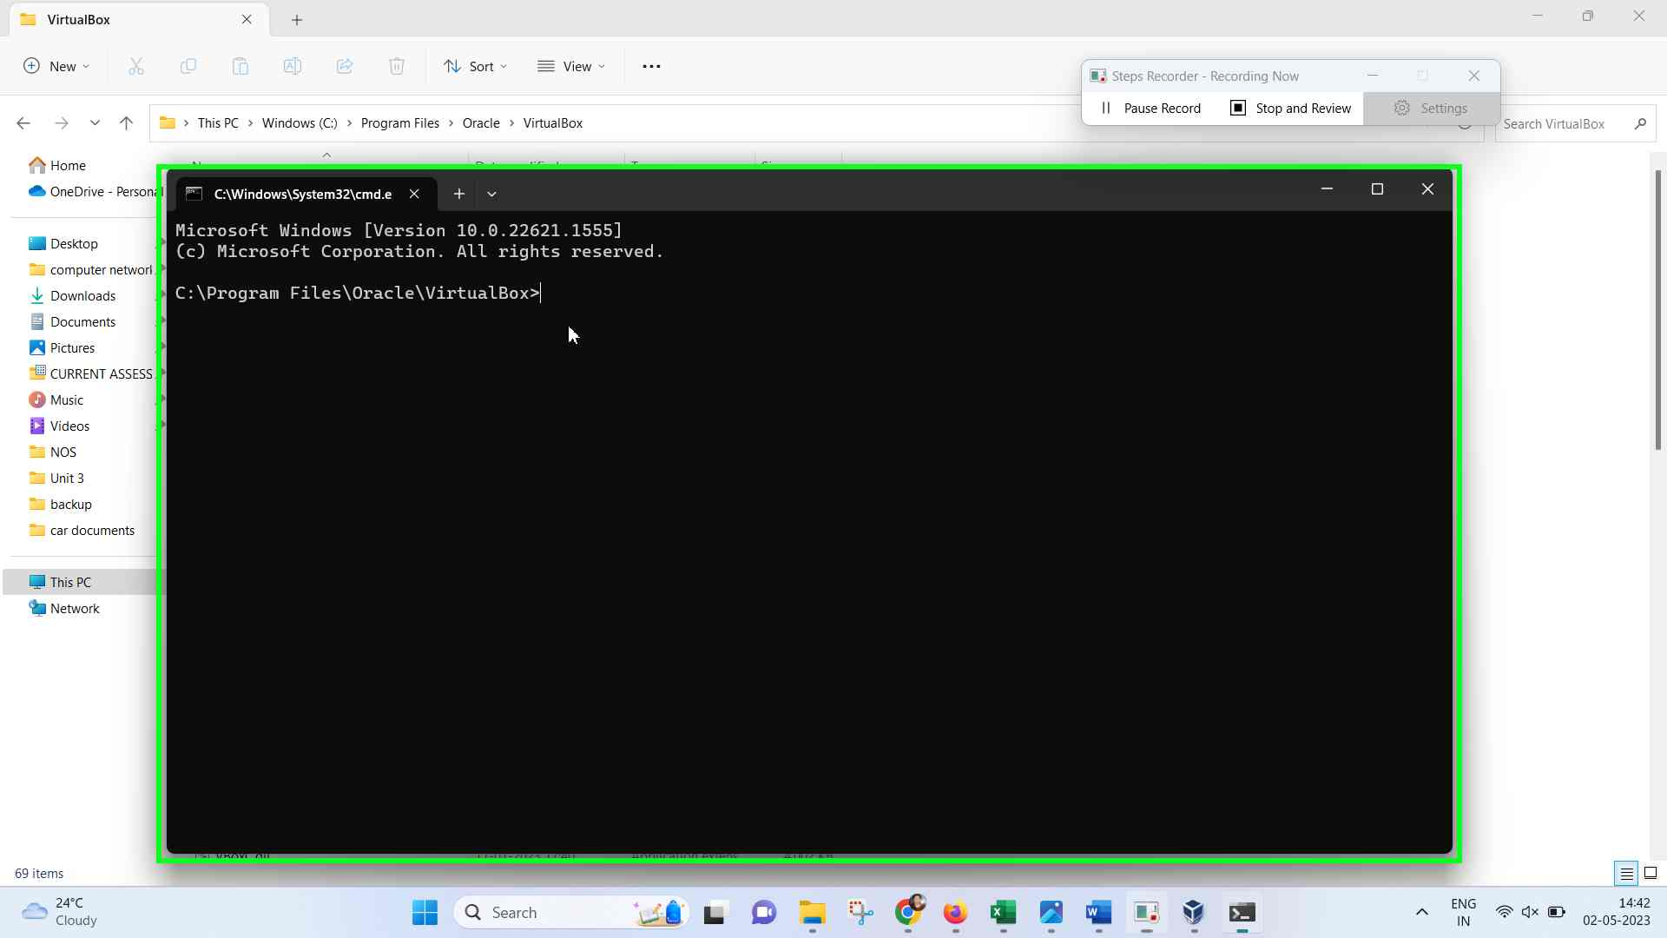Step 10 screenshot.

Previous Next

**Step 11: (‎02-‎05-‎2023 14:42:43)** User left click on "Recorded Steps - Google Chrome (list item)"



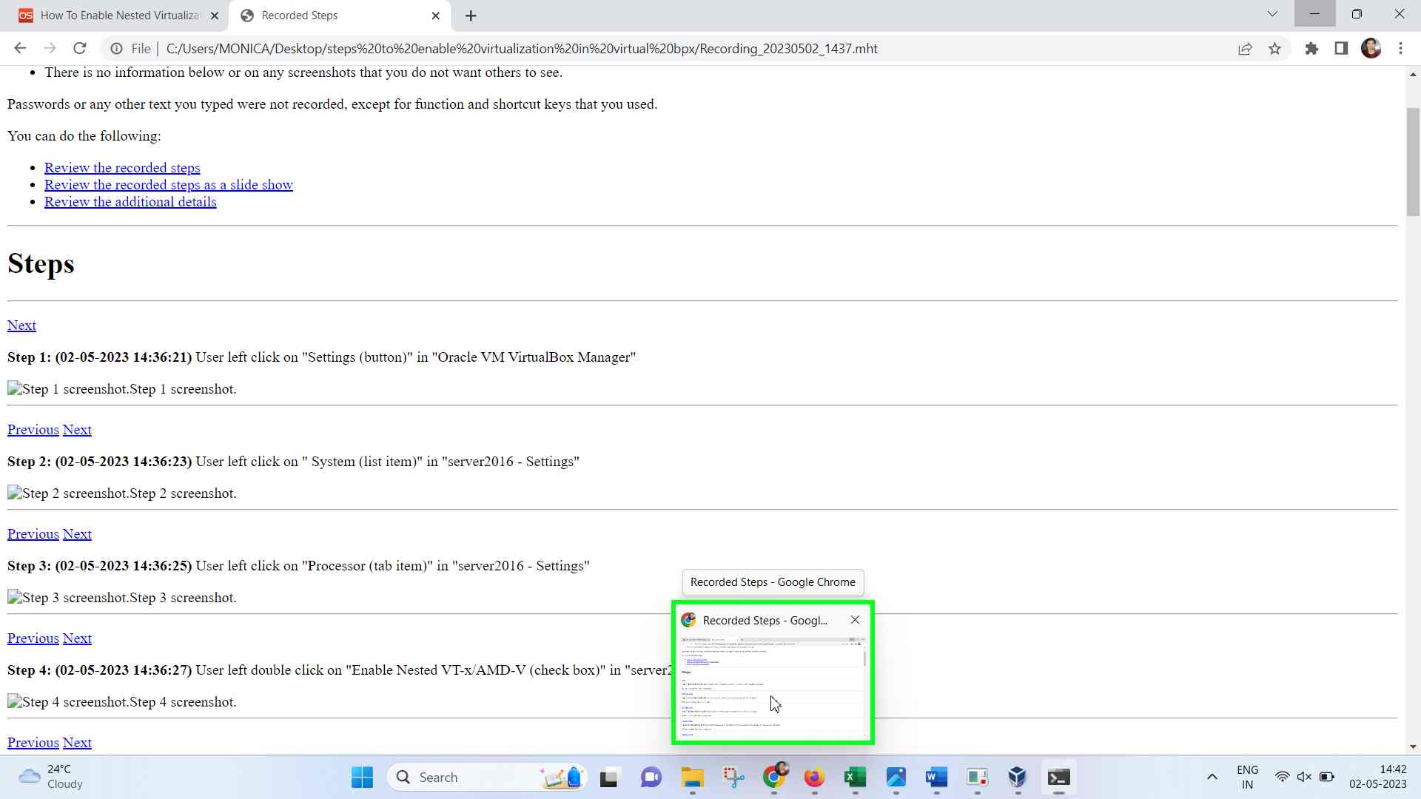Step 11 screenshot.

Previous Next

**Step 12: (‎02-‎05-‎2023 14:42:44)** User left click on "How To Enable Nested Virtualization In VirtualBox - OSTechNix - Google Chrome - Monica (pane)" in "Recorded Steps - Google Chrome"



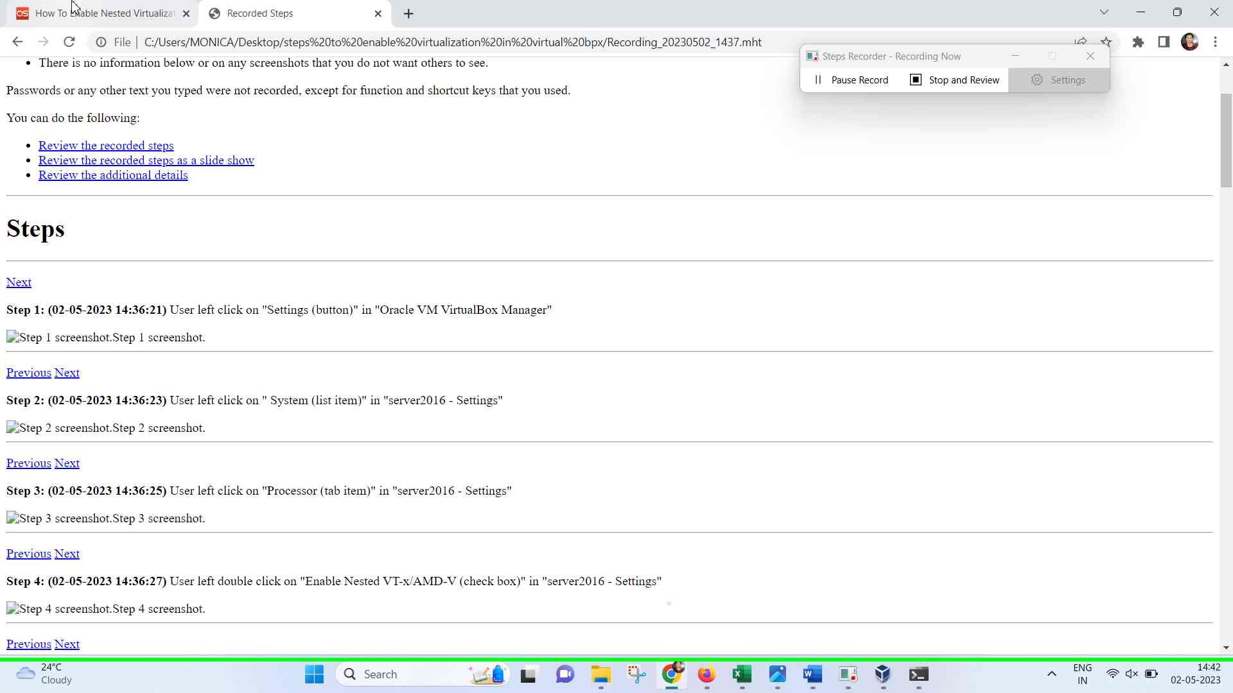Step 12 screenshot.

Previous Next

**Step 13: (‎02-‎05-‎2023 14:42:46)** User mouse drag start on "How To Enable Nested Virtualization In VirtualBox - OSTechNix (document)" in "How To Enable Nested Virtualization In VirtualBox - OSTechNix - Google Chrome"



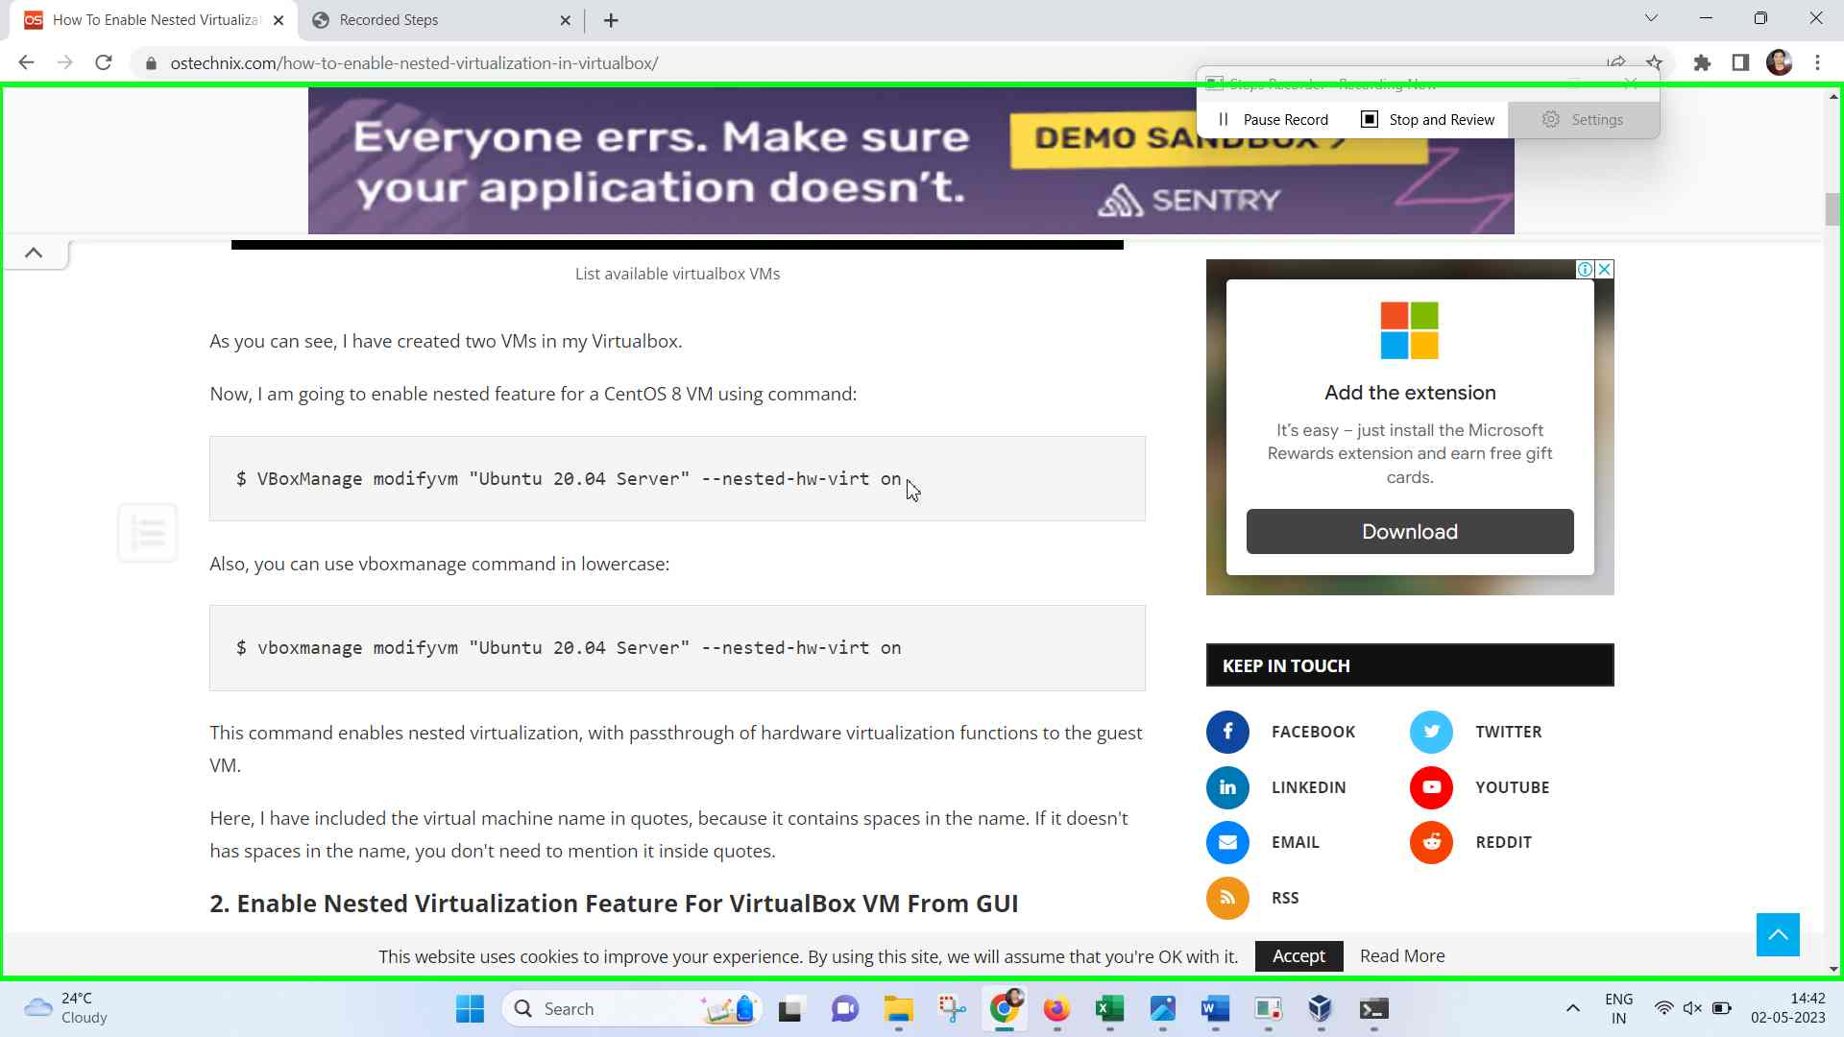Step 13 screenshot.

Previous Next

**Step 14: (‎02-‎05-‎2023 14:42:48)** User mouse drag end on "How To Enable Nested Virtualization In VirtualBox - OSTechNix (document)" in "How To Enable Nested Virtualization In VirtualBox - OSTechNix - Google Chrome"



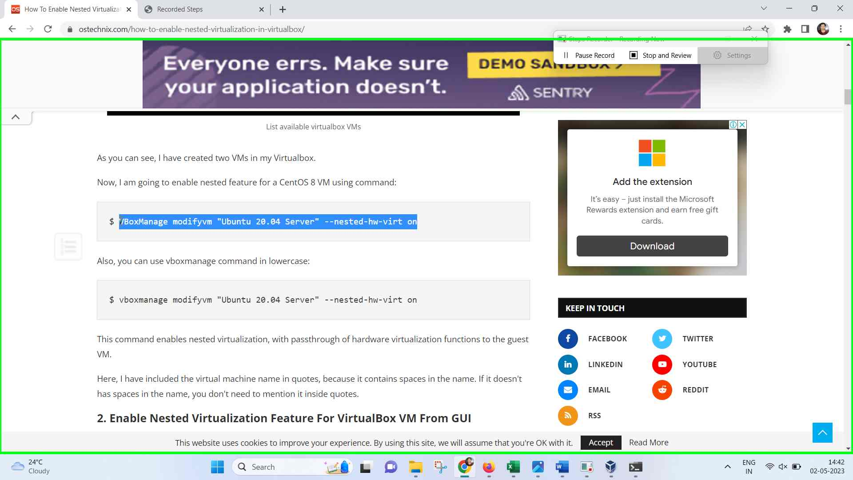Step 14 screenshot.

Previous Next

**Step 15: (‎02-‎05-‎2023 14:42:49)** User keyboard input on "How To Enable Nested Virtualization In VirtualBox - OSTechNix - Google Chrome - Monica (pane)" in "How To Enable Nested Virtualization In VirtualBox - OSTechNix - Google Chrome" [... Ctrl-C]



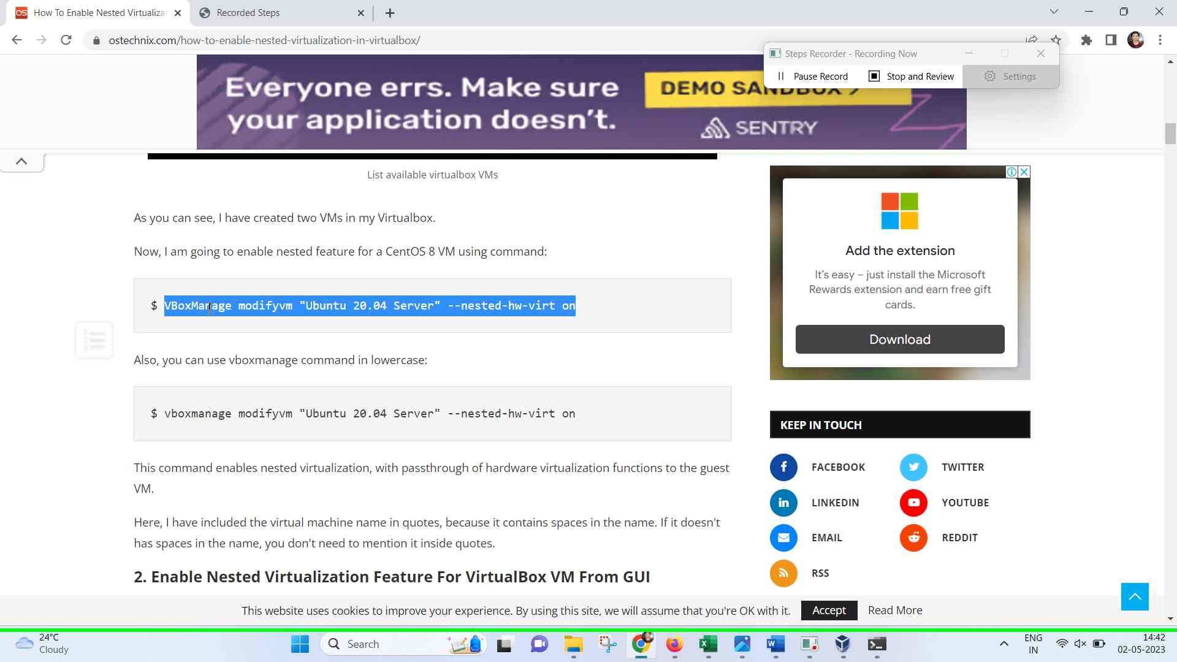Step 15 screenshot.

Previous Next

**Step 16: (‎02-‎05-‎2023 14:42:50)** User left click on "How To Enable Nested Virtualization In VirtualBox - OSTechNix - Google Chrome - Monica (pane)" in "How To Enable Nested Virtualization In VirtualBox - OSTechNix - Google Chrome"



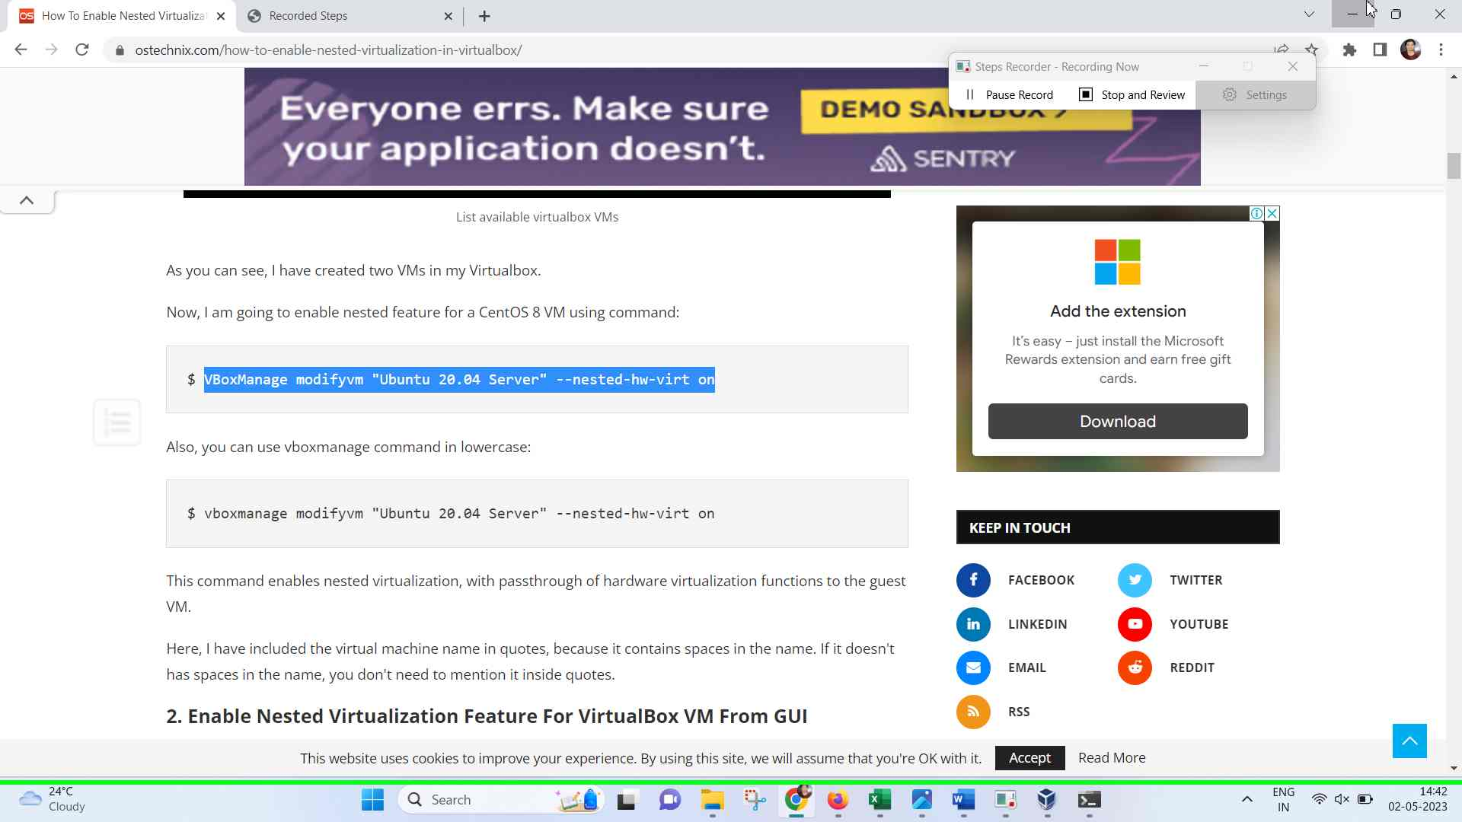Step 16 screenshot.

Previous Next

**Step 17: (‎02-‎05-‎2023 14:42:51)** User right click on "Command Prompt (terminal)" in "C:\Windows\System32\cmd.exe"



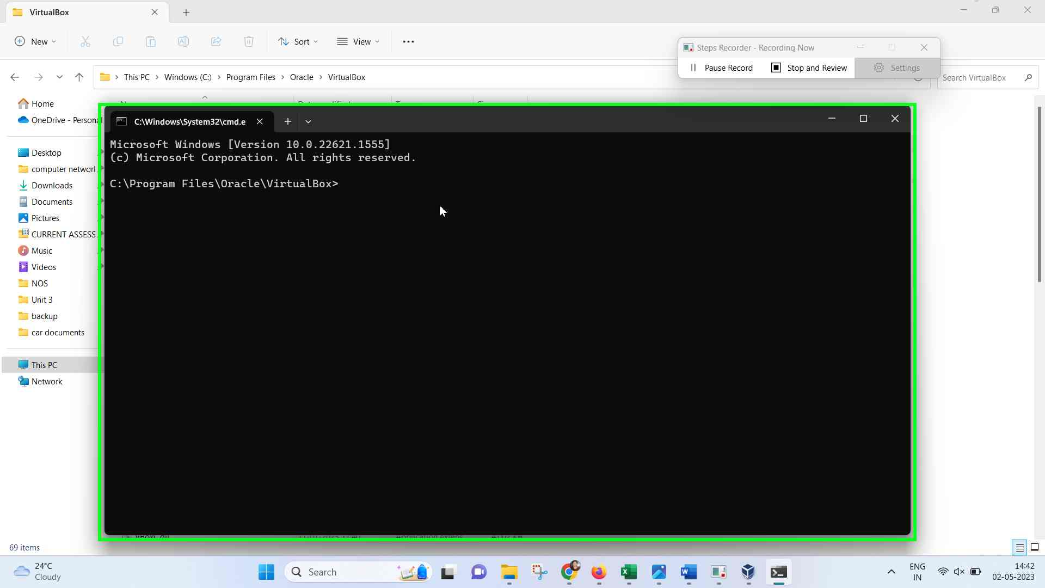Step 17 screenshot.

Previous Next

**Step 18: (‎02-‎05-‎2023 14:42:52)** User keyboard input on "DesktopWindowXamlSource (pane)" in "C:\Windows\System32\cmd.exe" [Left Left Left Left Left Left Left Left Left Left Left Left Left Left Left Left Left Left Left Left Left Left Left Right Right Right Backspace Backspace Backspace Backspace Backspace Backspace Backspace Backspace Backspace Backspace Backspace Backspace Backspace Backspace Backspace Backspace Backspace Backspace Backspace Backspace Backspace ... Enter]



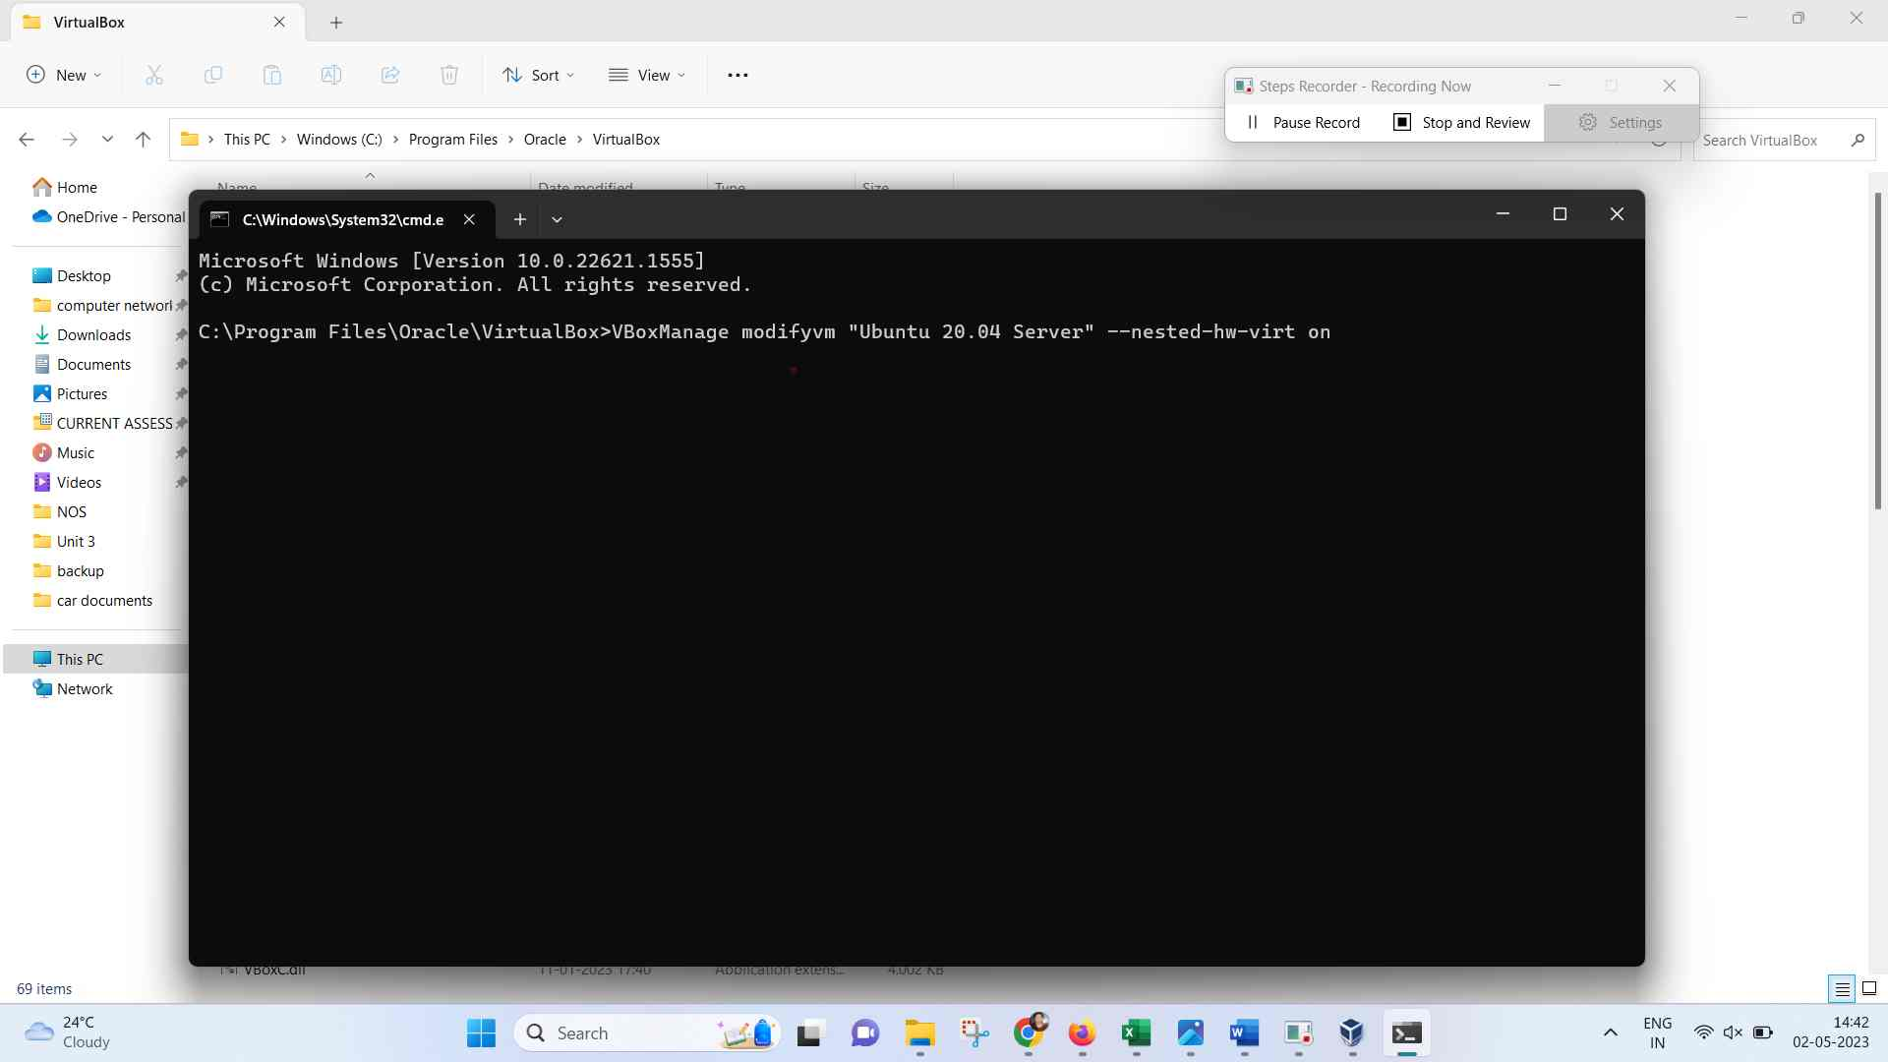Step 18 screenshot.

Previous Next

**Step 19: (‎02-‎05-‎2023 14:43:03)** User left click on "Oracle VM VirtualBox - 1 running window (button)"



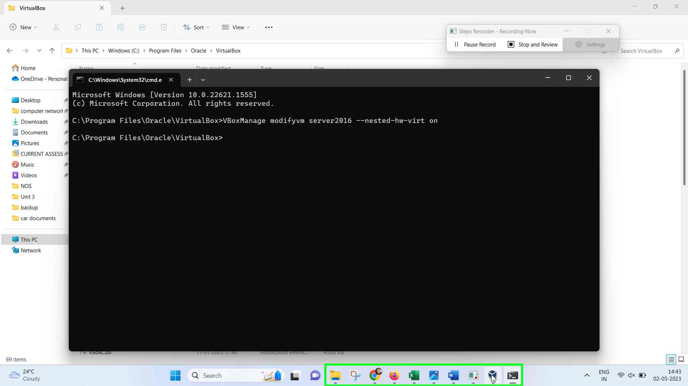Step 19 screenshot.

Previous Next

**Step 20: (‎02-‎05-‎2023 14:43:05)** User left double click on "server2016 - Settings (window)" in "server2016 - Settings"



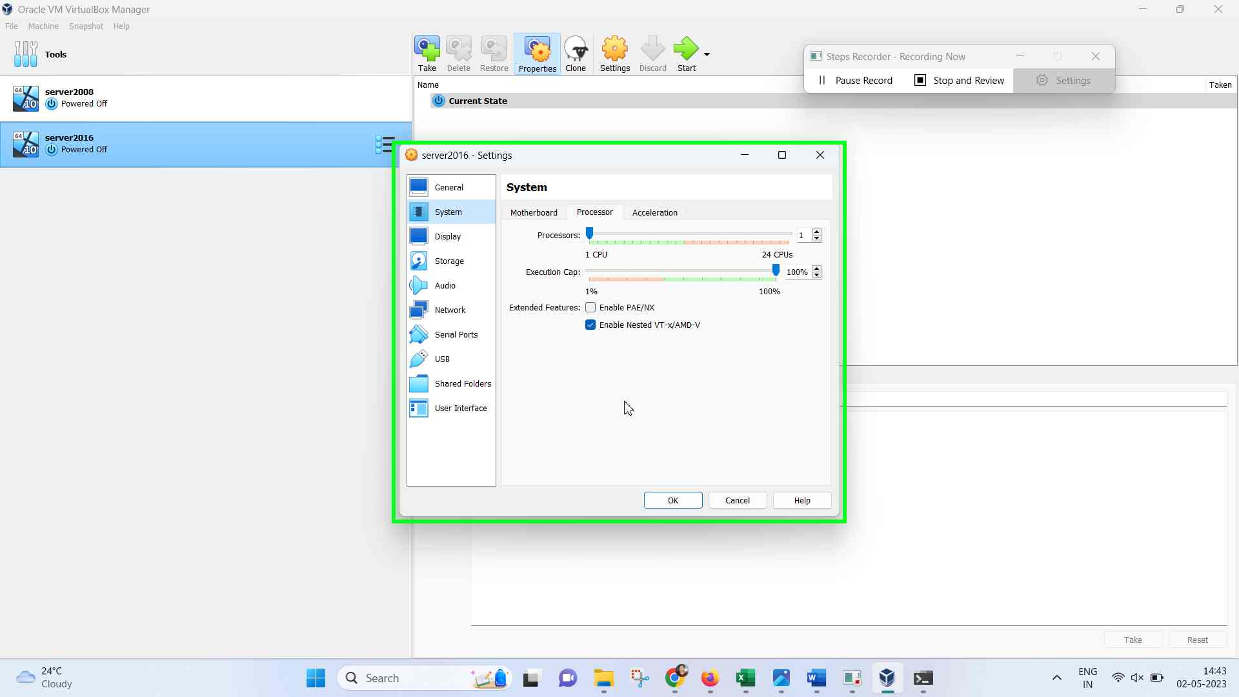Step 20 screenshot.

Previous

**Step 21: (‎02-‎05-‎2023 14:43:06)** User left click on "OK (button)" in "server2016 - Settings"



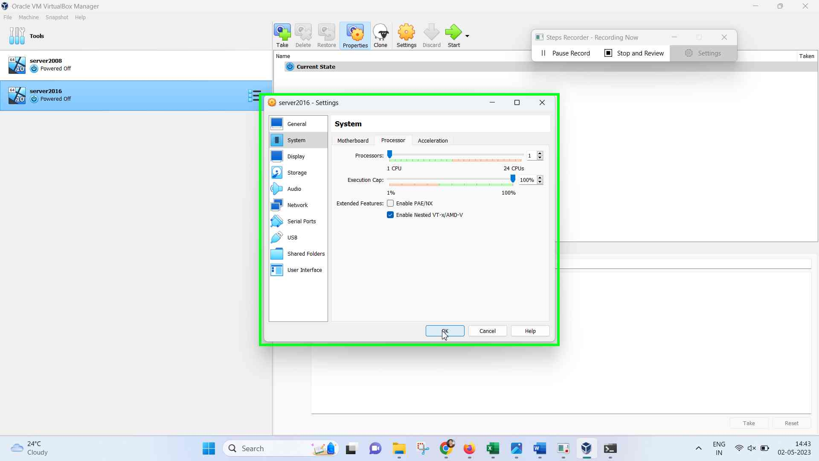Step 21 screenshot.

Additional Details

The following section contains the additional details that were recorded.

These details help accurately identify the programs and UI you used in this recording.

This section may contain text that is internal to programs that only very advanced users or programmers may understand.

Please review these details to ensure that they do not contain any information that you would not like others to see.

Recording Session: ‎02-‎05-‎2023 14:42:04 - 14:43:09  
  
Recorded Steps: 21, Missed Steps: 0, Other Errors: 0  
  
Operating System: 22621.1.amd64fre.ni_release.220506-1250 10.0.0.0.2.100  
  
Step 1: User left double click on "Oracle VM VirtualBox (list item)" in "Program Manager"  
Program: Windows Explorer, 10.0.22621.1 (WinBuild.160101.0800), Microsoft Corporation, EXPLORER.EXE, EXPLORER.EXE  
UI Elements: Oracle VM VirtualBox, Desktop, SysListView32, SHELLDLL_DefView, Program Manager, Progman  
  
Step 2: User left click on "Settings (button)" in "Oracle VM VirtualBox Manager"  
Program: VirtualBox Manager, 7.0.6.155176, Oracle and/or its affiliates, VIRTUALBOX.EXE, VIRTUALBOX.EXE  
UI Elements: Settings, QToolButton, QIToolBar, QWidget, QISplitter, UIVirtualBoxManagerWidget, Oracle VM VirtualBox Manager, UIVirtualBoxManager  
  
Step 3: User left click on " System (list item)" in "server2016 - Settings"  
Program: VirtualBox Manager, 7.0.6.155176, Oracle and/or its affiliates, VIRTUALBOX.EXE, VIRTUALBOX.EXE  
UI Elements: System , QITreeWidgetItem, Allows to navigate through VM Settings categories, QITreeWidget, QWidget, server2016 - Settings, UISettingsDialogMachine, Oracle VM VirtualBox Manager, UIVirtualBoxManager  
  
Step 4: User left click on "Processor (tab item)" in "server2016 - Settings"  
Program: VirtualBox Manager, 7.0.6.155176, Oracle and/or its affiliates, VIRTUALBOX.EXE, VIRTUALBOX.EXE  
UI Elements: Processor, Processor, QTabBar, QITabWidget, UIMachineSettingsSystem, QStackedWidget, QWidget, QWidget, server2016 - Settings, UISettingsDialogMachine, Oracle VM VirtualBox Manager, UIVirtualBoxManager  
  
Step 5: User left double click on "Enable Nested VT-x/AMD-V (check box)" in "server2016 - Settings"  
Program: VirtualBox Manager, 7.0.6.155176, Oracle and/or its affiliates, VIRTUALBOX.EXE, VIRTUALBOX.EXE  
UI Elements: Enable Nested VT-x/AMD-V, QCheckBox, UIProcessorFeaturesEditor, QWidget, QStackedWidget, QITabWidget, UIMachineSettingsSystem, QStackedWidget, QWidget, QWidget, server2016 - Settings, UISettingsDialogMachine, Oracle VM VirtualBox Manager, UIVirtualBoxManager  
  
Step 6: User left click on "File Explorer - 3 running windows (button)"  
Program: Windows Explorer, 10.0.22621.1 (WinBuild.160101.0800), Microsoft Corporation, EXPLORER.EXE, EXPLORER.EXE  
UI Elements: File Explorer - 3 running windows, Taskbar.TaskListButtonAutomationPeer, Taskbar.TaskbarFrameAutomationPeer, Windows.UI.Input.InputSite.WindowClass, DesktopWindowXamlSource, Windows.UI.Composition.DesktopWindowContentBridge, Taskbar, Shell_TrayWnd  
  
Step 7: User left click on "VirtualBox (list item)"  
Program: Windows Explorer, 10.0.22621.1 (WinBuild.160101.0800), Microsoft Corporation, EXPLORER.EXE, EXPLORER.EXE  
UI Elements: VirtualBox, Task Switcher, TaskListThumbnailWnd  
  
Step 8: User left click on "Address: C:\Program Files\Oracle\VirtualBox (tool bar)" in "VirtualBox"  
Program: Windows Explorer, 10.0.22621.1 (WinBuild.160101.0800), Microsoft Corporation, EXPLORER.EXE, EXPLORER.EXE  
UI Elements: Address: C:\Program Files\Oracle\VirtualBox, ToolbarWindow32, Breadcrumb Parent, Loading, msctls_progress32, Address Band Root, ReBarWindow32, WorkerW, VirtualBox, CabinetWClass  
  
Step 9: User keyboard input on "Address (edit)" in "VirtualBox" [Left ... Enter]  
Program: Windows Explorer, 10.0.22621.1 (WinBuild.160101.0800), Microsoft Corporation, EXPLORER.EXE, EXPLORER.EXE  
UI Elements: Address, Edit, Address, ComboBox, C:\Windows\System32\cmd.exe, ComboBoxEx32, Loading, msctls_progress32, Address Band Root, ReBarWindow32, WorkerW, VirtualBox, CabinetWClass  
  
Step 10: User right click on "Command Prompt (terminal)" in "C:\Windows\System32\cmd.exe"  
Program: WINDOWSTERMINAL.EXE -EMBEDDING, WINDOWSTERMINAL.EXE  
UI Elements: Command Prompt, TermControl, Windows.UI.Input.InputSite.WindowClass, DesktopWindowXamlSource, Windows.UI.Composition.DesktopWindowContentBridge, C:\Windows\System32\cmd.exe, CASCADIA_HOSTING_WINDOW_CLASS  
  
Step 11: User left click on "Recorded Steps - Google Chrome (list item)"  
Program: Windows Explorer, 10.0.22621.1 (WinBuild.160101.0800), Microsoft Corporation, EXPLORER.EXE, EXPLORER.EXE  
UI Elements: Recorded Steps - Google Chrome, Task Switcher, TaskListThumbnailWnd  
  
Step 12: User left click on "How To Enable Nested Virtualization In VirtualBox - OSTechNix - Google Chrome - Monica (pane)" in "Recorded Steps - Google Chrome"  
Program: Google Chrome, 112.0.5615.138, Google LLC, CHROME.EXE, CHROME.EXE  
UI Elements: How To Enable Nested Virtualization In VirtualBox - OSTechNix - Google Chrome - Monica, Chrome_WidgetWin_1  
  
Step 13: User mouse drag start on "How To Enable Nested Virtualization In VirtualBox - OSTechNix (document)" in "How To Enable Nested Virtualization In VirtualBox - OSTechNix - Google Chrome"  
Program: Google Chrome, 112.0.5615.138, Google LLC, CHROME.EXE, CHROME.EXE  
UI Elements: How To Enable Nested Virtualization In VirtualBox - OSTechNix, Chrome_RenderWidgetHostHWND, How To Enable Nested Virtualization In VirtualBox - OSTechNix - Google Chrome - Monica, Chrome_WidgetWin_1  
  
Step 14: User mouse drag end on "How To Enable Nested Virtualization In VirtualBox - OSTechNix (document)" in "How To Enable Nested Virtualization In VirtualBox - OSTechNix - Google Chrome"  
Program: Google Chrome, 112.0.5615.138, Google LLC, CHROME.EXE, CHROME.EXE  
UI Elements: How To Enable Nested Virtualization In VirtualBox - OSTechNix, Chrome_RenderWidgetHostHWND, How To Enable Nested Virtualization In VirtualBox - OSTechNix - Google Chrome - Monica, Chrome_WidgetWin_1  
  
Step 15: User keyboard input on "How To Enable Nested Virtualization In VirtualBox - OSTechNix - Google Chrome - Monica (pane)" in "How To Enable Nested Virtualization In VirtualBox - OSTechNix - Google Chrome" [... Ctrl-C]  
Program: Google Chrome, 112.0.5615.138, Google LLC, CHROME.EXE, CHROME.EXE  
UI Elements: How To Enable Nested Virtualization In VirtualBox - OSTechNix - Google Chrome - Monica, Chrome_WidgetWin_1  
  
Step 16: User left click on "How To Enable Nested Virtualization In VirtualBox - OSTechNix - Google Chrome - Monica (pane)" in "How To Enable Nested Virtualization In VirtualBox - OSTechNix - Google Chrome"  
Program: Google Chrome, 112.0.5615.138, Google LLC, CHROME.EXE, CHROME.EXE  
UI Elements: How To Enable Nested Virtualization In VirtualBox - OSTechNix - Google Chrome - Monica, Chrome_WidgetWin_1  
  
Step 17: User right click on "Command Prompt (terminal)" in "C:\Windows\System32\cmd.exe"  
Program: WINDOWSTERMINAL.EXE -EMBEDDING, WINDOWSTERMINAL.EXE  
UI Elements: Command Prompt, TermControl, Windows.UI.Input.InputSite.WindowClass, DesktopWindowXamlSource, Windows.UI.Composition.DesktopWindowContentBridge, C:\Windows\System32\cmd.exe, CASCADIA_HOSTING_WINDOW_CLASS  
  
Step 18: User keyboard input on "DesktopWindowXamlSource (pane)" in "C:\Windows\System32\cmd.exe" [Left Left Left Left Left Left Left Left Left Left Left Left Left Left Left Left Left Left Left Left Left Left Left Right Right Right Backspace Backspace Backspace Backspace Backspace Backspace Backspace Backspace Backspace Backspace Backspace Backspace Backspace Backspace Backspace Backspace Backspace Backspace Backspace Backspace Backspace ... Enter]  
Program: WINDOWSTERMINAL.EXE -EMBEDDING, WINDOWSTERMINAL.EXE  
UI Elements: Windows.UI.Input.InputSite.WindowClass, DesktopWindowXamlSource, Windows.UI.Composition.DesktopWindowContentBridge, C:\Windows\System32\cmd.exe, CASCADIA_HOSTING_WINDOW_CLASS  
  
Step 19: User left click on "Oracle VM VirtualBox - 1 running window (button)"  
Program: Windows Explorer, 10.0.22621.1 (WinBuild.160101.0800), Microsoft Corporation, EXPLORER.EXE, EXPLORER.EXE  
UI Elements: Oracle VM VirtualBox - 1 running window, Taskbar.TaskListButtonAutomationPeer, Taskbar.TaskbarFrameAutomationPeer, Windows.UI.Input.InputSite.WindowClass, DesktopWindowXamlSource, Windows.UI.Composition.DesktopWindowContentBridge, Taskbar, Shell_TrayWnd  
  
Step 20: User left double click on "server2016 - Settings (window)" in "server2016 - Settings"  
Program: VirtualBox Manager, 7.0.6.155176, Oracle and/or its affiliates, VIRTUALBOX.EXE, VIRTUALBOX.EXE  
UI Elements: QWidget, QStackedWidget, QITabWidget, UIMachineSettingsSystem, QStackedWidget, QWidget, QWidget, server2016 - Settings, UISettingsDialogMachine, Oracle VM VirtualBox Manager, UIVirtualBoxManager  
  
Step 21: User left click on "OK (button)" in "server2016 - Settings"  
Program: VirtualBox Manager, 7.0.6.155176, Oracle and/or its affiliates, VIRTUALBOX.EXE, VIRTUALBOX.EXE  
UI Elements: OK, QPushButton, QIDialogButtonBox, QWidget, server2016 - Settings, UISettingsDialogMachine, Oracle VM VirtualBox Manager, UIVirtualBoxManager

Return to top of page...